Budget Rent A Car 
of British Columbia

Global Information System

Security Business Design

Version 2.00

Note: The information contained in this document is confidential and may not be disclosed to any parties outside of Budget Rent a Car of British Columbia without written consent by one of its officers.
Copyright (C) 2000 Budget Rent a Car of British Columbia
Table of Contents
1. Functional Area Business Design 1
1.1. GIS Security 1
1.1.1. Preventing Unauthorized Use by Non GIS Users 1
1.1.1.1. External (Outside Budget) 1
1.1.1.2. Internal (Within Budget) 1
1.1.2. Controlling Use by GIS Users 2
1.1.2.1. GIS Components 2
1.1.2.1.1. Menu 2
1.1.2.1.2. Screens 2
1.1.2.1.3. Batch Processes 3
1.1.2.1.4. Reports 3
1.1.2.2. User Group 4
1.1.2.3. Locations 4
1.1.2.4. User Access to Multiple Workstations Within a Location 5
1.1.2.5. Permission Level Definition 7
1.1.2.6. GIS/Platinum Replication 7
1.1.2.7. GIS Database 7
1.1.3. System Maintenance 7
1.1.4. Appendix 1: GIS Security Architecture Diagram 9
1.1.5. Appendix 2: User Group Permissions 10
2. Revision History 25
2.1. Version 2.00 25

Functional Area Business Design

GIS Security
The purpose of security in GIS is to ensure that only authorized users are allowed to access the system and its data. Once in the system, the security will ensure that users have access to only the components for which they have been granted permission. As well, in a given component the security will ensure that the user may only complete actions for which they have permission.
The GIS security operates primarily by recognising and authenticating a user and the terminal they are using at signon, GIS then identifies their user group by the user id. The user group is used to determine what privileges are granted for the GIS components. Restrictions based on anything other than user group are enforced at the application level in the GIS component.
Appendix 1 shows a diagram of the GIS Security Architecture.

Preventing Unauthorized Use by Non GIS Users

External (Outside Budget)
GIS operates on the Budget BC Intranet. It is physically separated from the Internet where general public access is available. This means that in order to access GIS, a user must have access to the Budget Internal Network. There are no external links to the Budget Internal Network with the exception of Eigen. Security for the Eigen link will be addressed separately. The Security for Internal access is described below.

Internal (Within Budget)
Access to the GIS system will only be allowed by authorized users on recognized Budget terminals. Security restricts access to the front-end or screen level, the back end or database level, and the middle level or MTS business objects.
Accessing the GIS system is a two step process. The user must first sign on to the NT system so that they have access to Budget’s local intranet. The second step, signing onto the GIS system, is described below.
To sign onto the GIS system the user will open their browser and invoke GIS. They will then be required to enter a user name and password (GIS Signon). This may be a different user name and password from that used for the NT Signon (but must be a valid NT user name and password). A user name and password will have to be provided for each browser that is running GIS. If a valid user name and password is not entered for the GIS system, access is denied. To prevent an individual from bypassing the GIS Signon and accessing the GIS main screen directly (by entering the GIS main screen URL), when the GIS main screen is invoked, a check will be made to ensure that the GIS Signon was completed within the last five seconds. This will be accomplished with the use of a timestamp that is updated by location upon successful GIS Signon and user group recognition (CSR Logon Time table). The URL for the other GIS screens is hidden and therefore will not require the timestamp check.

Controlling Use by GIS Users
Upon GIS Signon, when the user is authenticated by their password, GIS will get the user group from a table that stores user groups and their members (GIS UserGroup). Once the user group is known, GIS can refer to the Access Permission table where the information about which components a user group has access to is stored.

GIS Components
The GIS Components may be defined as the parts of the system that are accessed by authorized individuals to use or operate the system.

Menu
The menus are visible upon entering the GIS main screen. The menus are grouped by functional area such as Fleet, Rate Control, Reservations, and Contracts. Security by menu item is required to prevent a user from selecting a menu item for which they do not have authority.
Based on the user group the GIS main screen will display the appropriate function menu. Only functions for which the user group has at least view (read only) access will be included and visible in the function menu.

Screens
Security at the screen level can be split into two categories, accessing the screen, and accessing specific restricted functions (overrides) on the screen.
General Access
Access to the screens will be restricted to users who are authorized to view, create, update, or delete information in the screen. At screen initialization, GIS will check the Access Permission table to ensure that the appropriate level of access is allowed.
Specific Overrides
In some screens there are specific functions that require additional security. Typically these are overrides that require a manager or supervisors approval. Specific overrides are required in the following areas:
- Reservations (logon password override, availability override, maestro reservation rate update, forfeit discount override)
- Contract Open and Check Out (logon password override, availability override, discounts)
- Changes During Rental (logon password override, availability override, do not extend override)
- Contract Check In (logon password override, discounts)
- Foreign Contract Check In (logon password override, discounts)
- Contract Adjustments (logon password override, check out/check in adjustment, RBR date override)
- Accessory Sales (logon password override)
For these sections of the screen where specific overrides are required, appropriate permission will be determined by the user group. If the current user does not have the appropriate override permission, then GIS will present a dialogue box that prompts the user to enter a user name and password. GIS will verify that the user has permission to access the special function. This will allow for a different individual from the current user to complete the special function. Upon exiting the special function the original user id will be considered to be still active for the underlying function from which the special function was invoked.

Batch Processes
Security for batch processes can be categorized into two areas as described below. In either case security defined by user group is not required for the batch processes.
Batch Processes Triggered from Other Processes or The Scheduler
These will be automatically run by GIS or the scheduler, for example: nightly posting to Platinum and G/L. The scheduler will only be available on one of the servers and access will be restricted to an authorized administrator. There is no special security for batch processes triggered from other processes other than the security for the invoking process.
Re-Runs of Failed Batch Processes
When a batch process fails, the re-running of it may be required. Only specifically authorized individuals (systems support) will be allowed to re-run batch processes.

Reports
On Request Reports
Security is required to restrict the users who are allowed to request the running of pre-defined reports and review the report results. Like the screen security, each user group will be given privileges for the set of reports required by that user group. Security limiting data by location, if required, will be implemented as described in the location section.
Scheduled Reports
Scheduled Reports will be set up by systems support. These reports will run automatically and therefore will not require user group security. Access to the scheduled report results will be controlled in the same way as access to On Request Reports is controlled (described above).

User Group
Security by user group (defined by role) will be used for GIS. This will classify individuals who perform the same role, such as reservation agent, into one group that will be assigned security permissions. Some samples of user groups that are based on roles are: Reservation Manager, Reservation CSR, Location Manager, and Location CSR.
User permissions will be defined in a single tier, that is, a single user id may only belong to one user group. The user groups will be assigned access permissions to each GIS component (menu, screens, and reports). The user group access permissions will be not vary by where (what location) the user is accessing the system.
Appendix 2 contains the User Group access permissions for the GIS Screens.

Locations
Security by location in GIS is required in a limited number of situations. Essentially this security is required to restrict the ability for a location to create or alter records that have been created at or for another location.
Since the location security requirements are not user group specific (a user’s access to screens, batch processes, and reports does not vary when they change locations), the security will be enforced at the application level. This means that, when required, GIS will limit what can be entered in a field or what data can be accessed or updated by the location of the terminal.
The location security will be enforced at the application level as described for each function below.
- Reservations:
- Rental locations can only create and update local reservations where that location is the pick up location. (Non-Rental Locations cannot create or update any reservations as they will be unable to select a pick up location.)
- RezNet may create and update local reservations where the pick up location is a rental location that accepts RezNet reservations. Whether a location is a rental location and whether it accepts RezNet reservations is defined in Location Maintenance.
- All reservations are available for viewing by all locations.
Note that a local reservation is a non-Maestro reservation. Security around who is able to update a Maestro reservation rate is classified as special function security under the ‘Screens’ section.
- Contracts:
- Rental locations can only use reservations to open contracts where that location is the pick up location in the reservation
- Rental locations may only open contracts without a reservation where the pick up location is the current location or a foreign (non-BRAC) location. Which owning company owns a location is defined in Location Maintenance.
- Non-Rental Locations (for example, head office) can use reservations to open contracts where the pick up location in the reservation is any BRAC rental location
- Non-Rental Locations can open contracts without a reservation for any pick up location.
- Reports:
- Rental Locations may be limited to only request reports on information that is pertinent to that location.
- Non-Rental Locations can request a report for any location applicable to the report.

User Access to Multiple Workstations Within a Location
The ability for a user to move from terminal to terminal quickly is required while still accurately logging the completed transactions to the appropriate user. These transactions will occur within screens when the user completes their activity by pressing a button on the screen, such as Save.
To achieve the flexibility of moving from terminal to terminal with minimum delay, the user transactions will be logged at the application level. This means that GIS will be already running with the appropriate screens invoked. The user will enter their id to allow them to use the already running application.
The GIS functions that require this type of security are:
- Reservations
- Contract Open and Check Out
- Changes During Rental
- Check In
- Foreign Contract Check In
- Contract Adjustments
- Accessory Sale

The GIS User Groups that will require this security for the functions listed above are:
- Location CSRs
- Location Manager
- Location SR
- Reznet CSR
- Reznet Supervisor
- Customer Service
- DOP Customer Service
- Fleet Control
- Operations
- Revenue Management
- Claims
- Shop

These usergroups will have Access Permissions that do not include logon password override permission. Usergroups that are granted the logon password override will automatically bypass the application level logon.
At the GIS Signon, GIS will write all the user names and passwords in the current user group to the local Current User registry. The user names and password are stored in a GIS table (CSR Password). A current list of all members in each of the user goups listed above will have to be maintained in this GIS table to ensure that each user will have an entry on the registry.
When a screen that has the logon password security is invoked, it will check the usergroup permission for a logon password override. If no override exists then GIS will then run a security program at the application level that operates on top of the GIS application. This application launches the Logon Password dialogue box. When the user wishes to use the running system (GIS Signon already complete) they will enter their password into the Logon Password dialogue box (which is displayed on top of the running application). Once a valid password is entered the dialogue box will disappear and the user will be allowed to use the current screen. All transactions completed will then be logged as completed by that user until the ‘end session’ or ‘quit’ button has been selected, or another screen has been selected..
The Logon Password dialogue box will display the current user group that is logged into GIS (current user group in the terminal registry). This displayed information is refreshed each time the dialogue box is launched. A cancel button is available in the Logon Password dialogue box. When the cancel button is selected, a screen will display that advises the user to re-log into GIS. A sample of the Logon Password Dialogue box is shown below:
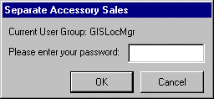
This application level security (Logon Password dialogue box) controls who is identified as completing the transactions. It does not control GIS component access; the NT Signon and GIS Signon (which occur prior to the application user level security) control GIS component access.

Permission Level Definition
The permission definition will be broken in three levels:
- No access
- View only access (Read only)
- Full access (Create, Read, Update, and Delete – provided the individual screens and fields allow each of these)
Each user group will be given one of these levels of access for each GIS component (menu, screens, reports). Note that special function (override) privileges will be granted to a user group for each special function.

GIS/Platinum Replication
There is no special security requirements surrounding GIS/Platinum Replication.

GIS Database
Access restrictions for the GIS database will be implemented through the front-end screen, and report security.

System Maintenance
System maintenance access is required to maintain ongoing functions (such as security and system data) as well as to fix any data problems that may arise. The system maintenance has been split into two categories below.
Security Administration Facilities
NT security administration is maintained by non-GIS functions outside the GIS system. Security administration of GIS security tables will be maintained using a system tool such as MS Query.
GIS and Production Support
Security will be required to restrict who can access tables directly in the database without going through the GIS screens. Only specific individuals should have access; this will be controlled by the NT Signon.

Appendix 1: GIS Security Architecture Diagram
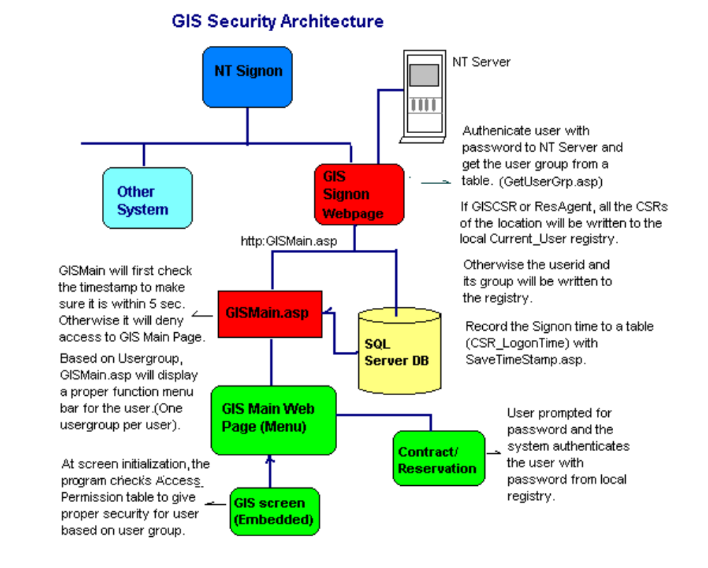

Appendix 2: User Group Permissions
(Stored in the Access Permissions table)
Contract User Group Permissions
N – No Access
V – View Only Access available in Vehicle Support only.
F – Full Access
+ - Full Access plus Access to the overrides on this screen.
User Group | Contract Open/Check Out |  |  |  | Changes During Rental |  |  |  | Contract Check In |  |  | Foreign Contract Check In |  |  | Contract Adjustments |  |  |  | Contract Search  (View Only) | Vehicle Support  (from GIS Menu) | Separate Accessory Sales |  | Location Vehicle Availability  (View Only)
 |  | Availability | Discount | Logon Password |  | Availability | Do Not Extend | Logon Password |  | Discount | Logon Password |  | Discounts | Logon Password |  | Check In/Out Adjustment | RBR Date | Logon Password |  |  |  | Logon Password
RezNet CSR | N |  |  |  | F |  |  |  | N |  |  | N |  |  | N |  |  |  | F | V | F |  | N
RezNet Supervisor | N |  |  |  | F | + | + |  | N |  |  | N |  |  | F |  | + |  | F | V | F |  | N
Location CSR | F |  |  |  | F |  |  |  | F |  |  | F |  |  | F |  |  |  | F | V | F |  | F
Location Manager | F | + | + |  | F | + | + |  | F | + |  | F | + |  | F |  | + |  | F | V | F |  | F
Location SR | N |  |  |  | N |  |  |  | N |  |  | N |  |  | N |  |  |  | F | N | N |  | F
Executive | F | + | + | + | F | + | + | + | F | + | + | F | + | + | F | + | + | + | F | F | F | + | F
Customer Service | N |  |  |  | F |  |  |  | N |  |  | N |  |  | F |  | + |  | F | V | F |  | F
DOP Customer Service | N |  |  |  | F |  | + |  | N |  |  | N |  |  | F |  |  |  | F | F | N |  | F
Fleet Control | N |  |  |  | F |  | + |  | N |  |  | N |  |  | F |  |  |  | F | N | N |  | F
Operations | F | + | + |  | F | + | + |  | F | + |  | F | + |  | F | + | + |  | F | F | F |  | F
Revenue Management | F | + | + |  | F | + | + |  | F | + |  | F | + |  | F | + | + |  | F | F | F |  | F
Marketing / Sales | N |  |  |  | F |  |  | + | N |  |  | N |  |  | F |  | + | + | F | N | F | + | N
Claims | N |  |  |  | F |  | + |  | F | + |  | N |  |  | F |  | + |  | F | F | N |  | F
Shop | N |  |  |  | F |  |  |  | N |  |  | N |  |  | F |  |  |  | F | V | N |  | F

Reservations User Group Permissions
N – No Access
V – View Only Access available in Truck Inventory only.
F – Full Access
+ - Full Access plus Access to the overrides on this screen.
User Group | Reservation Create/Update |  |  |  |  | Reservation Search  (View Only) | Truck Inventory Maintenance
 |  | Availability | Maestro Rate | Forfeit Discount | Logon Password
RezNet CSR | F |  |  |  |  | F | N
RezNet Supervisor | F | + |  | + |  | F | N
Location CSR | F |  |  |  |  | F | N
Location Manager | F | + | + | + |  | F | N
Location SR | N |  |  |  |  | N | N
Executive | F | + | + | + | + | F | F
Customer Service | F |  |  | + | + | F | N
DOP Customer Service | F |  |  |  | + | F | F
Fleet Control | N |  |  |  | + | N | N
Operations | F | + | + | + | + | F | F
Revenue Management | F | + | + | + | + | F | F
Marketing / Sales | N |  |  |  |  | N | N
Claims | N |  |  |  |  | N | N
Shop | N |  |  |  |  | N | V
Rate Control User Group Permissions
N – No Access
F – Full Access
+ - Full Access plus Access to the overrides on this screen.
User Group | Vehicle Rate Maintenance | Location Maintenance | Optional Extra Maintenance | Sales Accessory Maintenance | Exchange Rate Maintenance
RezNet CSR | V | N | N | N | N
RezNet Supervisor | F | F | N | N | N
Location CSR | N | N | N | N | N
Location Manager | N | N | N | N | N
Location SR | N | N | N | N | N
Executive | F | F | F | F | F
Customer Service | N | N | N | N | N
DOP Customer Service | N | N | N | N | N
Fleet Control | N | N | N | N | N
Operations | N | N | N | N | N
Revenue Management | F | F | F | F | F
Marketing / Sales | N | N | N | N | N
Claims | N | N | N | N | N
Shop | N | N | N | N | N
Sublicensees | N | N | N | N | N
Customer Profile User Group Permissions
N – No Access
V – View Only Access
F – Full Access
+ - Full Access plus Access to the overrides on this screen.
User Group | Organization Screen | Customer Screen
RezNet CSR | N | N
RezNet Supervisor | F | F
Location CSR | N | N
Location Manager | N | N
Location SR | N | N
Executive | F | F
Customer Service | N | N
DOP Customer Service | N | N
Fleet Control | N | N
Operations | V | V
Revenue Management | F | F
Marketing / Sales | V | V
Claims | V | F
Shop | V | V
Fleet Control User Group Permissions
N – No Access

F – Full Access
+ - Full Access plus Access to the overrides on this screen.
User Group | Add Vehicle to Fleet | Vehicle Status Update | Vehicle Movement | Add Foreign Vehicle | Record Vehicle Service | Restrict Rental Use | Program Information Update | Vehicle Inventory
RezNet CSR | N | N | N | N | N | N | N | N
RezNet Supervisor | N | N | N | N | N | N | N | N
Location CSR | N | N | F | F | F | N | N | N
Location Manager | N | N | F | F | F | N | N | N
Location SR | N | N | F | F | F | N | N | N
Executive | F | F | F | F | F | F | F | F
Customer Service | N | N | N | N | N | N | N | N
DOP Customer Service | F | F | F | F | F | F | F | F
Fleet Control | F | F | F | F | F | F | F | F
Operations | N | N | F | F | F | N | N | N
Revenue Management | N | N | F | F | F | N | N | F
Marketing / Sales | N | N | N | N | N | N | N | N
Claims | N | N | F | F | F | N | N | N
Shop | N | N | F | F | F | N | N | N

Fleet Control User Group Permissions Cont.
N – No Access
V – View Only Access
F – Full Access
+ - Full Access plus Access to the overrides on this screen.
User Group | Licence Plate Inventory | Licence Plate Generation | Vehicle Search – Single Record  (View Only) | Vehicle Search – Multiple Record  (View Only) | Vehicle Model/Year | Vehicle Class Maintenance | Owing Company Maintenance
RezNet CSR | N | N | N | N | N | N | N
RezNet Supervisor | N | N | N | N | N | N | N
Location CSR | N | N | F | F | N | N | N
Location Manager | N | N | F | F | N | N | N
Location SR | N | N | F | F | N | N | N
Executive | F | F | F | F | F | F | F
Customer Service | N | N | N | N | N | N | N
DOP Customer Service | N | N | F | F | N | N | N
Fleet Control | F | F | F | F | F | F | F
Operations | N | N | F | F | N | N | N
Revenue Management | N | N | F | F | F | F | F
Marketing / Sales | N | N | N | N | N | N | N
Claims | N | N | F | F | N | N | N
Shop | N | N | F | F | N | N | N

Reporting User Group Permissions
The reporting permissions will be determined in the reporting business design. The user groups will be the same as those defined for the screens (above).

Revision History

Version 2.00
- Clean up documentation and make consistent with the GIS standards.

